Computers and the Internet

1.Software or hardware ?

Put S(Software) or H(Hardware)next to each of the following words:

a hard drive | h | a laser printer | h
a mouse | h | an application | s
a pen drive | h | a spreadsheet | s
a keyboard | h | a media player | h
an antivirus | s | an operating system | s
a scanner | h | a word processor | s

Which of the above devices or programmes would you use to…

- make a copy of your screen on paper?
A laser printer
- make a copy of a sheet of paper on your screen?
A scanner
- store data and transfer it to another computer?
A hard drive
- protect your computer from harmful programs?
An antivirus
- double-click on an icon?
An operating sytem
- play music or videos?
A media player
- type out an email or document?
A spreadsheet
- calculate your monthly expenses?
A spreadsheet or an application

2. Icons
Look at the icon set below. Match the words to the correct icons.

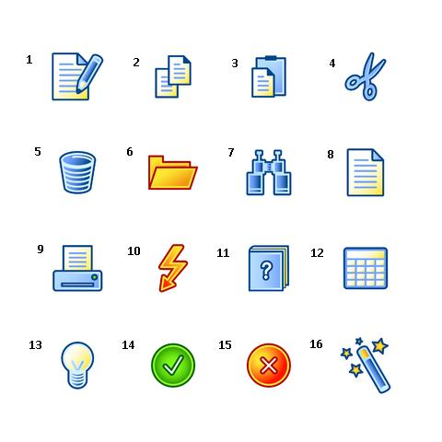
1. Edit 5.trash bin 13. Help
2. Copy 6. 14. accept
3. Paste 7. Search 15. Decline
4. Cut. 8. Folder 16. Edit
9. Print 12.calcualtor

3.On the Internet

Complete the email below putting the following verbs in the correct form.

go
upload

While I was surfing the net, I came across an interesting website offering the cooking recipes for lots of tasty dishes from all over the world.I love cooking so I decided to fill in the online registration form and sign up for a free account. After I browse a few pages, I found a recipe that I really wanted to try, so I decided to scroll down the bottom of the page and click on the download link in order to download it in pdf format. The next day, I decided to invite some of my friends for dinner, so I went on Google and search for some cooking websites.I bookmark a few interesting ones, so now I can find them again easily whenever I go online.Anyway, the dinner party was a great success. I’ll upload the pictures to my Instagram profile !

4. Types of websites

Match the types of website on the left with the activities on the right.
1.social networking websites b | a.buying and selling goods, bidding on items
2.blogs h | b.connecting with friends, sharing pictures
3.forums f | c.doing courses online
4.auction websites a | d.downloading/uploading large files, e.g music and films
5.file sharing websites d | e.finding websites, surfing the net
6.search engines. e | f.participating in discussions and posting comments on a specific topic
7.e-learning websites. c | g.sending and receiving emails
8.webmail sites. g | h.writing an online diary

5. Branching out
A. Guess the website
Think of a well-known website, but do not tell the other students who will try to guess
by asking yes/no questions such as:
- Can you download music/films?
YES
- Can you connect with friends?
YES
- Is it free to sign up?
YES
- Can you/Is it possible to/Do users….?

